**Reinhardt, Max** **(1873-1943)**

Born Max Goldmann to Jewish parents in Baden, Austria and nicknamed ‘The Magician’ by the press, Max Reinhardt was pivotal in establishing theatre directing as an art form in the early twentieth century. Although he apprenticed as an actor in naturalist productions directed by Otto Brahm at the Deutsches Theater in Berlin from 1893 to 1903, he built his reputation by championing expressionism and other anti-realist theatrical movements in productions that toured throughout Europe and the United States. Reinhardt’s eclectic roster, from spectacular stagings of Shakespeare to intimate productions of plays by Frank Wedekind and August Strindberg, brought innovative production methods and experimental drama to a mass audience, while training major figures in modern theatre and film, including Bertolt Brecht, Erwin Piscator, and Ernst Lubitsch.

Reinhardt challenged the prominence of naturalism in the midnight cabaret he co-founded in a hotel in Berlin in 1901, first called ‘Die Brille’ (the glasses) and then ‘Schall und Rauch’ (sound and smoke). Featuring satirical sketches, song and dance, and attendants dressed as pierrots, ‘Schall und Rauch’ expanded into the Kleines Theater, which staged the German premiere of Oscar Wilde’s symbolist play *Salome* in 1902. Reinhardt broke his acting contract with the Deutsches Theater to run the Kleines Theater and another venue, the Neues Theater, full-time in 1903.

In 1905, Reinhardt premiered his production of *A Midsummer Night’s Dream* to enormous acclaim. In addition to a revolving stage that allowed one scene to flow into another, Reinhardt lavished attention on the gods and fairies and used simulated moonlight, Felix Mendelssohn’s music, and a forest of papier-mache trees. The *Dream* became Reinhardt’s signature production and, thanks to the 1935 Warner Brothers film starring James Cagney and Mickey Rooney, his most widely seen work. He was offered the directorship of the Deutsches Theater the same year and bought it outright in 1906.

Reinhardt’s Kammerspiele (chamber theatre), which he opened next door to the Deutsches Theater in 1906, was the model for small experimental theatres throughout Europe and North America. Reinhardt gained international renown, however, for his enormous spectacles. His 1910 production of Sophocles’ *Oedipus Rex*, modeled on the massive proportions of Greek amphitheatres, opened in Berlin at the Circus Schumann, which Reinhardt later purchased and christened the Grosses Schauspielhaus (great theatre) in 1919. In London, *Oedipus* played Covent Garden and included a chorus of drama students and boy scouts whose hundreds of swaying arms evoked a nation of worshippers. For *The Miracle* in 1911, a pageant about a nun’s fall from grace, Reinhardt converted Olympia, London’s largest covered space, into a Gothic cathedral with stained-glass windows three times the size of the Rose Window in Notre Dame Cathedral. Audiences of 8,000 formed a congregation in mock pews throughout the structure.

After World War I, new impresarios who worked to politicize mass audiences overshadowed Reinhardt’s sensuous fantasies in Berlin. In 1920, with composer Richard Strauss, conductor Bruno Walter, and playwright Hugo von Hoffmansthal, Reinhardt opened the annual Salzburg Festival in Austria. The festival specialized in grand-scale productions of medieval and baroque morality plays such as Hoffmansthal’s updated *Everyman*. In 1933, the Nazi party forced Reinhardt to surrender his German theatres and he emigrated from Austria to the United States in 1937. Although Reinhardt did not duplicate his phenomenal success in America, he founded an acting school in Hollywood and continued to direct operas, Shakespeare, and modern plays until his death in 1943.

**References and Further Reading**

Fuhrich, Edda, and Gisela Prossnitz. (1993) *Max Reinhardt: The Magician’s Dreams* Vienna: Residenz-Verlag.

Reinhardt, Gottfried. (1979) *The Genius: a Memoir of Max Reinhardt by His Son*, New York: Knopf.

Sayler, Oliver. (1924) *Max Reinhardt and His Theatre*, New York: Brentano’s.

Styan, J. L. (1982) *Max Reinhardt*, Cambridge: Cambridge University Press.

**Lawrence Switzky, University of Toronto**

**Recommended Illustrations**

**[Note: please use all four recommended illustrations if possible in order to give a visual sense of Reinhardt’s directorial aesthetic.]**

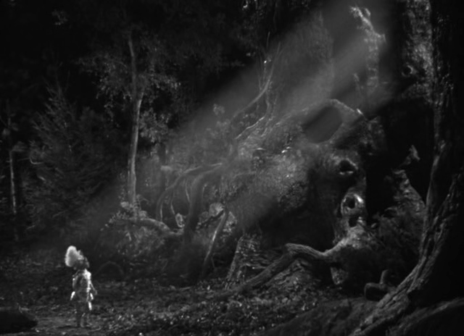

**Still from the film of *A Midsummer Night’s Dream*, dir. Max Reinhardt and William Dieterle (1935).**

[Available at: <http://houseofmirthandmovies.wordpress.com/2009/12/17/20-shots-from-a-midsummer-nights-dream-william-dieterle-max-reinhardt-1935/#jp-carousel-2276>]

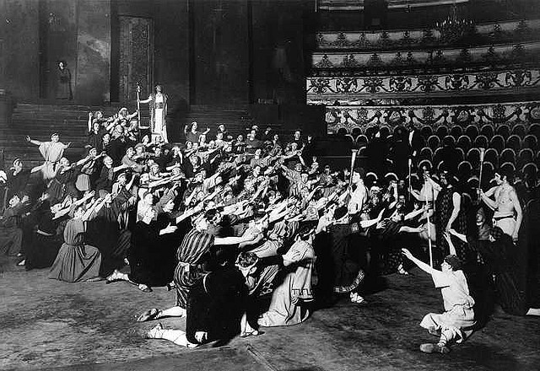

**Max Reinhardt’s production of *Oedipus Rex* at the Circus Schumann (1930).**

[Available at: <http://theredlist.com/wiki-2-20-881-1400-view-topics-2-profile-antique.html>]

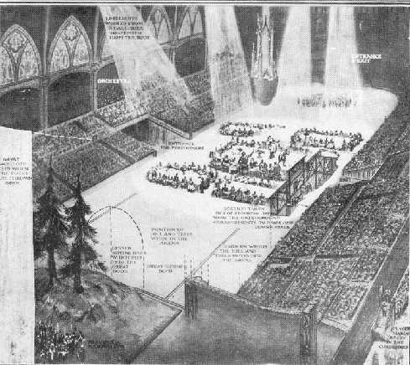

**Production design for *The Miracle* at Olympia in London (1911).**

[Available at: <http://oud.digischool.nl/ckv2/moderne/moderne/reinhardt/MaxReinhardt.htm>]

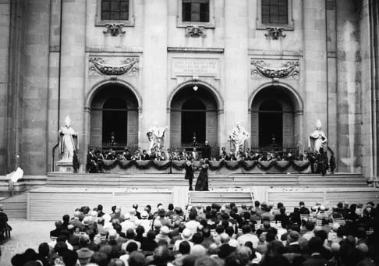

**Max Reinhardt's production of *Everyman* at the Salzburg Festival with Alexander Moissi (Everyman), Johanna Terwin (Paramour) and Werner Krauss (Death) (1920).**

[Available at: <http://www.salzburgerfestspiele.at/history/1920> ]